**COMPUTER NETWORKS**

**LAB ASSIGNMENT DOCUMENTATION**

**POOJA A**

**RA2211026050031**

**III CSE AIML A**

Lab 1: Implementation of Network Topologies Procedure:

1. Open Packet Tracer:

* Launch Cisco Packet Tracer on your computer.

1. Implement a Bus Topology:

* Drag three computers onto the workspace.
* Connect them using a single backbone cable (Coaxial Cable).

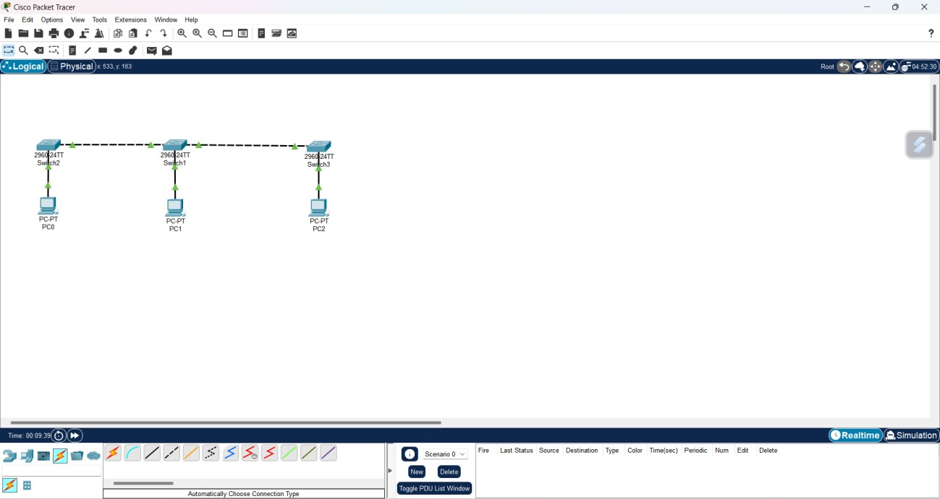

1. Implement a Star Topology:

* Drag three computers and a switch onto the workspace.
* Connect each computer to the switch using straight-through Ethernet cables.

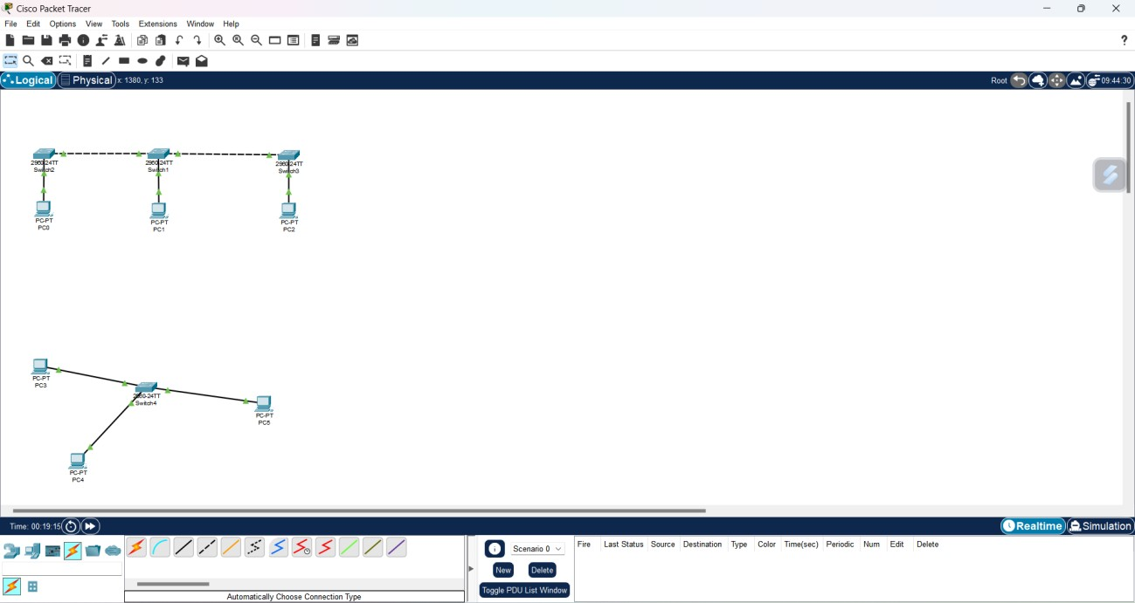

1. Implement a Ring Topology:

* Drag three computers onto the workspace.
* Connect them in a circular manner using crossover cables.

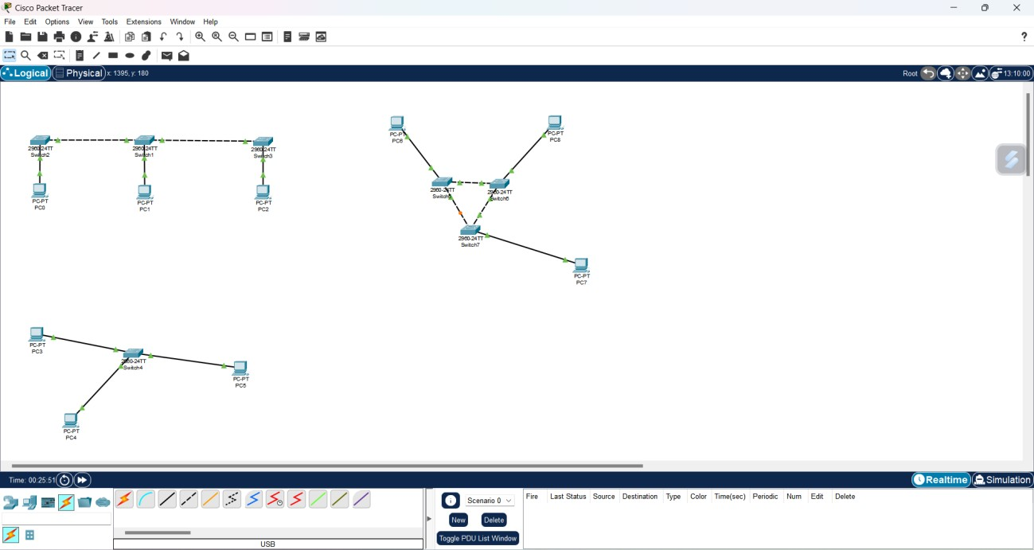

1. Implement a Mesh Topology:

* Drag three computers onto the workspace.
* Connect each computer to every other computer using crossover cables.

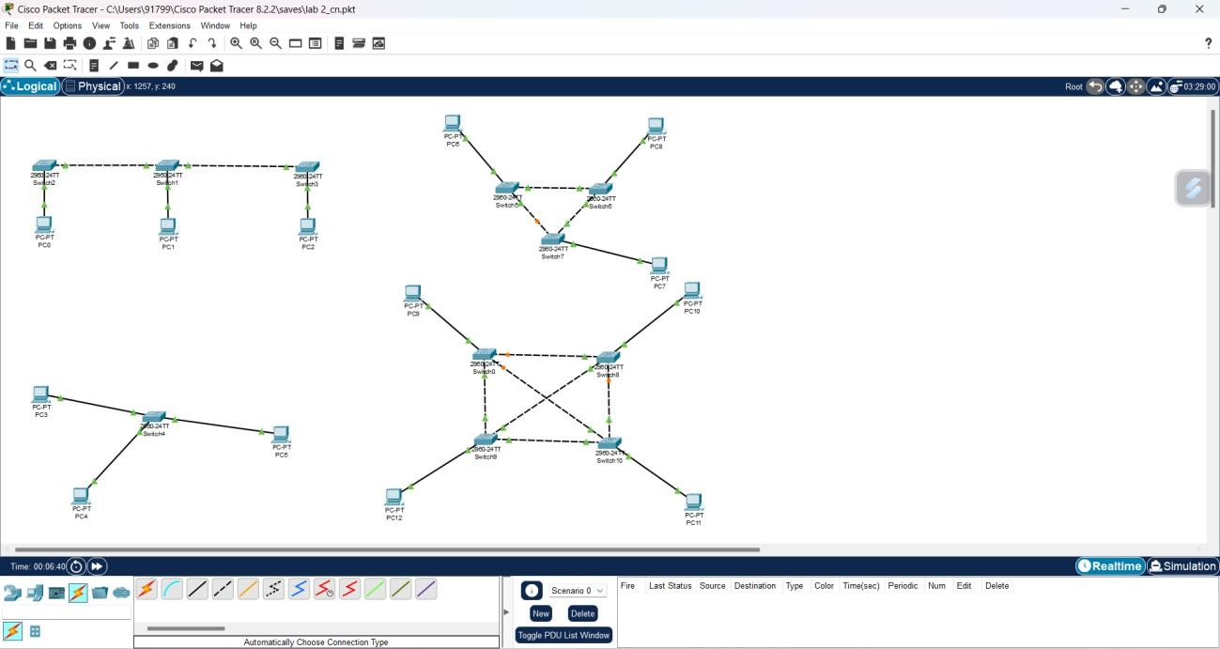

1. Test Connectivity:

* For each topology, assign IP addresses to the computers.
* Use the “ping” command to test connectivity between all computers.

